Lab7Bai1

Chay lenh trc

npm install @react-navigation/native npm install @react-navigation/bottom-tabs npm install react-native-screens react-native-safe-area-context react-native-gesture-handler react-native-reanimated react-native-vector-icons expo install expo-font

Code file app

import React from "react";

import { NavigationContainer } from "@react-navigation/native";

import Lab71 from "./lab7bai1";

const App = () => {

  return (

    <NavigationContainer>

      <Lab71 />

    </NavigationContainer>

  );

};

export default App;

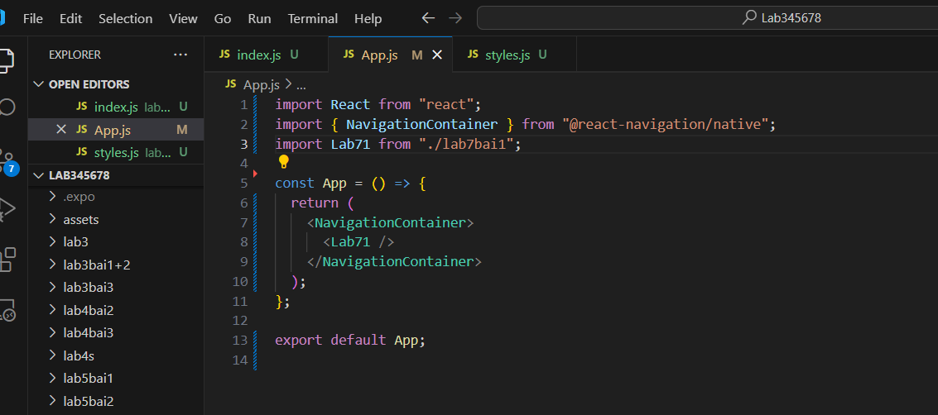

Lab72

Nho import dau cau lenh nay

expo install react-native-tab-view

import React from "react";

import { View } from "react-native";

import TopTabs from "./Lab7Bai2/index";

const App = () => {

  return (

    <View style={{ flex: 1 }}>

      <TopTabs />

    </View>

  );

};

export default App;

Lab73

npm install @react-navigation/native @react-navigation/bottom-tabs react-native-screens react-native-safe-area-context react-native-gesture-handler react-native-reanimated react-native-vector-icons react-native-pager-view react-native-tab-view

bên dưới là cần thiết để chạy lab7

import React from "react";

import { NavigationContainer } from "@react-navigation/native";

import BottomTabs from "./lab7bai3/BottomTab/index"; // Đảm bảo đường dẫn đúng

export default function App() {

  return (

    <NavigationContainer>

      <BottomTabs />

    </NavigationContainer>

  );

}